Intensificación primer cuatrimestre 2do año

ACTIVIDADES

A)READ AND WRITE TRUE OR FALSE
My name is Micaela and I’ from Perú. I live in Trujillo. I am thirteen years old. I live with my dad, Roberto and my mum Lucia. My eldest brother is Juan, he is sixteen years old and my little brother is a baby, Mateo. Sasha is my cat. It is orange. I love my family.
Answer
1-Where`s Micaela from?
2-What`s her mum`s name?
3- Has he got a sister?
4- Is Mateo her cat?

Write a short paragraph about you. Use the text about Micaela as a model.
(redacta un párrafo corto con tu información personal, similar al de Micaela)

My name is ………………………………………………………………………………………………………………………………….. …………………………………………………………………………………………………………………………………………………………………………………………………………………………………………………………………………………………………………………………………………………………………………………………………………………………………………………………………………………………………………………………………………………………………………………………………………………………………………
B) 1.Verb to be. Complete the chart (AM-IS-ARE)

He
She
it
We
You
they

I

2.Choose the correct option.

- My teacher …… Laura
a) are is) am)
- I …… twelve years old
a) are is) am)
- Lucia and Mike ……. my best friends
a) are is) am)

3. Write the sentences above into the negative form. (Escribi las oraciones de arriba en la forma negative)

…………………………………………………………………………………………
…………………………………………………………………………………………
…………………………………………………………………………………………

4.To be. Questions and short answers
Order the words to make questions
- big/is/your city? …………………………………………………
- Happy/are/you and your classmates? ……………………………………………………..
- From the USA/is/your teacher? ………………………………………………………………
- You/are/from/japan…………………………………………………………….
- Summers in your country/hot/are? ………………………………………………………….

Now math the questions from the previous exercise with the answers a-e.

a Yes, she is.
b No, they aren’t.
c Yes, I am.
d No, it isn’t.
e Yes, we are

5.Order the sentences to make a conversation. (ordena las oraciones para formar una conversación, enumeralas)

Keira: No, I’m not. I’m from Ireland. Fabio- that’s not an English name. ____

Keira:Yes, I’m . My name’s Keira. ____

Fabio: Yes, they are! They are from Milan. ____

Fabio. Hi! I’m Fabio. Where are you from, Keira? Are you English? ____
Keira: wait- are they Italian? ____
Fabio: No, it isn’t. I’m from England, but my mum and dad. ____

Fabio: Hi! Are you new in this school? __1__

6.Rewrite the dialogue with contracted forms (transcribe usando la forma abreviada de “to be”

Hi! I am Claudia and this is my friend Jorge. He is 14. We are from Natal. It is a city in Brazil.

HI! Claudia. I am Berta and these are my friends, Lola and Julia. They are from Barcelona. I am from Valencia.
C) Occupations. Entra al enlace, escucha el audio y arrastra las imágenes al lugar correcto.
https://images.app.goo.gl/YUdBhKnBH8fhiGZRA

Intensificación 3er año—Primer cuatrimestre
Las siguientes actividades serán realizadas en el celular (on line activities). Aquellos que no dispongan de celular se les entregará fotocopias.

A-Verb to be- Past- Completa
https://images.app.goo.gl/AyxbVK2cqYpmHG8P9

B_Past time expressions

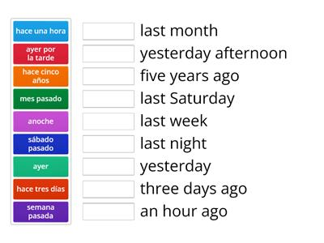

C-Lectura Comprensiva: Lee y resuelve las actividades
https://images.app.goo.gl/Haa6xTQGwUhqZJkR9

Intensificación 4to año- primer cuatrimestre

Actividades
A-Entra al enlace y realiza las actividades
https://images.app.goo.gl/vn7sqdah8jXys2A79

B-Escucha el audio y une con las imágenes. Luego completa las oraciones con will/won´t
https://images.app.goo.gl/iACzLqzqFs9Ch37K9
C-Lectura Comprensiva: 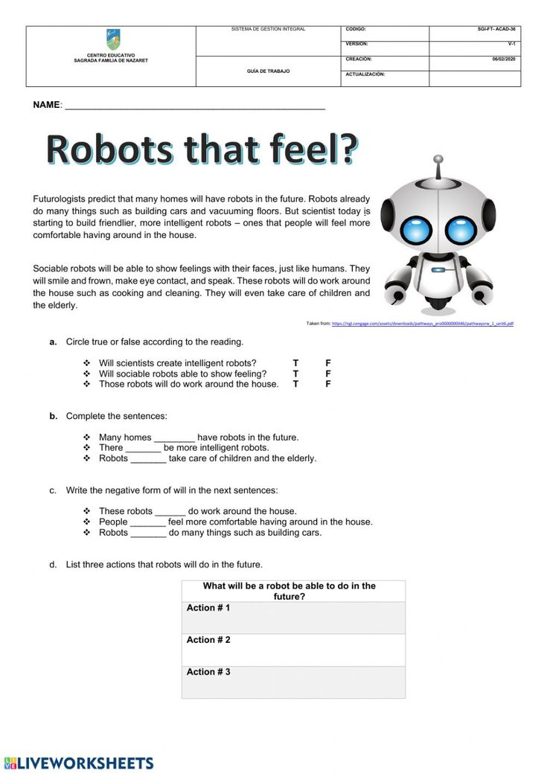
6to año A. Primer cuatrimestre

A) Tiempos verbales. Repaso. Presentes y pasados

https://images.app.goo.gl/JzRH6XxWYbT1SjRc7
B) Lectura comprensiva: lee y resuelve las actividades
https://images.app.goo.gl/KTN5jcAavPqRvjuh6

